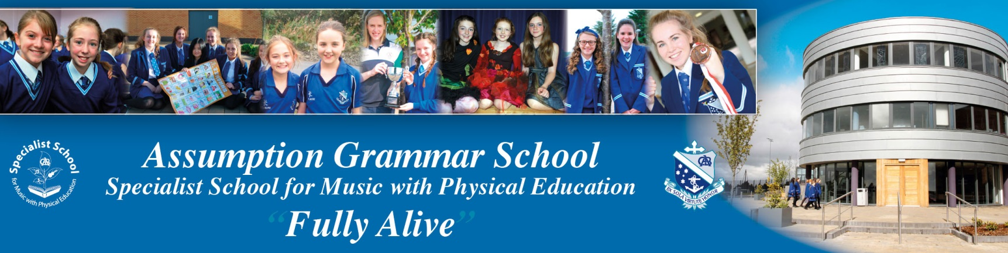
Required for 1 September 2022:

The Board of Governors invites applications for the following posts:

1 Head of Physics (Permanent Post)

2 Teacher of Mathematics to A2 Level and Physics to GCSE (Permanent Post)

3 Teacher of Biology to A2 Level (Permanent Post)

4 Teacher of Physical Education with ability to teach Health & Social Care (Temporary Post - 1 September 2022-31 August 2023)

Application Form, Job Description and Personnel Specification are available from the school’s website. Completed application forms must be returned by email to the Principal’s PA (rloughran236@c2ken.net) by 9.30 am on Monday 16 May 2022.

All candidates will be informed via email whether or not they have been shortlisted for interview.

It is the responsibility of applicants to ensure that all information is included on the application form. Canvassing in any form will disqualify. Assumption Grammar School is an Equal Opportunities Employer and welcomes applications for all posts regardless of gender, community background, religion, political affiliation, race or disability.

Posts involving work in educational institutions are subject to the provisions of the Protection of Children and Vulnerable Adults (NI) Order 2003.

